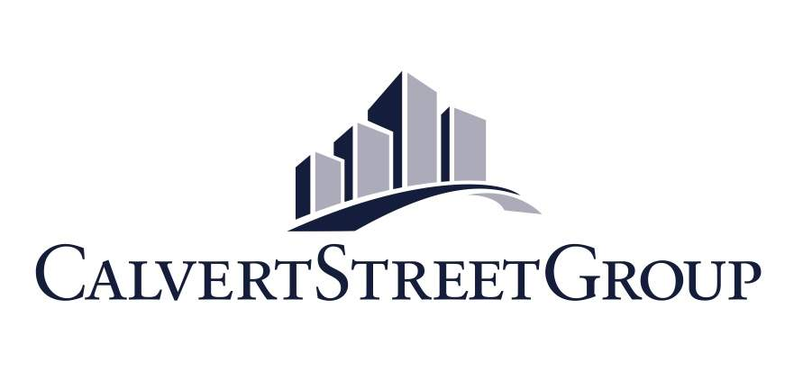
Political Science Internship Listing

CSG is now accepting applications for a unique opportunity to serve as campaign manager and/or campaign coordinator for the Metro Davidson County (Nashville) Council. 35 District representatives, 5 At-Large, and the Vice Mayor are all up for election to the Metro Council. Election Day is Thursday, August 4, 2011.

Description:

The Calvert Street Group has immediate openings for campaign managers/coordinators in its Nashville, Tennessee office. Internships will be unpaid, and CSG supervisors will work with your learning institution and/or professor to assist in receiving academic credit.

The position will entail working with incumbents, challengers, and open seat candidates as they seek election to the Metro Council. Metro Council candidates are non-partisan, but we will try to match up managers with candidates based on various criteria.

Managers will be given a macro overview of political campaign basics, along with a micro review of Metro Davidson County elections. Additionally, campaign managers will be provided with relevant reading materials to help tie theory to practice. You will be a valuable and integral part of the candidate’s campaign. Your work will directly affect the outcome of the election. No answering phones at this internship.

Preference will be given to candidates with Nashville residency, previous campaign experience, and/or database management knowledge.

About the Calvert Street Group:

The Calvert Street is a leading public affairs corporate and political consulting firm focusing on state and local affairs, land-use and development, and grassroots lobbying. For more information, visit: www.calvertstreetgroup.com

To Apply:

Submit a brief cover letter and resume to info@calvertstreetgroup.com, with “Council Internship” in the subject field. Please include your dates of availability. No phone calls please.

